Challenge: Extraterrestrial Persistence

# Challenge Description :

**There is a rumor that aliens have developed a persistence mechanism that is impossible to detect. After investigating her recently compromised Linux server, Pandora found a possible sample of this mechanism. Can you analyze it and find out how they install their persistence?**

# Context :

## We are given a bash script that contains a base64 string when decoded we are given the flag.

# Notes :

* Tools:
  + - Text editor - To open the bash script / downloaded files.
    - You can choose your way to decoding the base64 string for simplicity im going to use a website, “www.base64decode.org”

# Flag :

* Download the file and open it up. It is pretty obvious what the strings are.

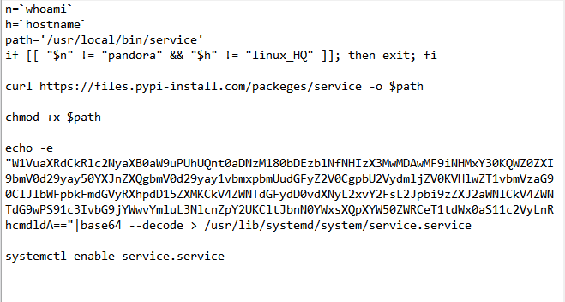

* When we decode the string we get

[Unit]

Description=HTB{th3s3_4l13nS_4r3_s00000_b4s1c}

After=network.target network-online.target

[Service]

Type=oneshot

RemainAfterExit=yes

ExecStart=/usr/local/bin/service

ExecStop=/usr/local/bin/service

[Install]

WantedBy=multi-user.target

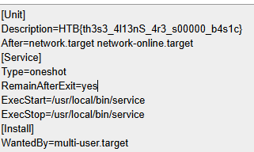

* Giving us the flag: **HTB{th3s3_4l13nS_4r3_s00000_b4s1c}**